Name: Shridhar Ajit Ashtikar
Roll No.: 77

Practical No. 1

Theory

LEX:
Lex is a program generator designed for lexical processing of character input streams. It accepts a high level, problem-oriented specification for character string matching, and produces a program in a general purpose language which recognizes regular expressions. The regular expressions are specified by the user in the source specifications given to Lex. The Lex written code recognizes these expressions in an input stream and partitions the input stream into strings matching the expressions. At the boundaries between strings program sections provided by the user are executed. The Lex source file associates the regular expressions and the program fragments. As each expression appears in the input to the program written by Lex, the corresponding fragment is executed.
Lex is not a complete language, but rather a generator representing a new language feature which can be added to different programming languages, called ``host languages.'' Just as general purpose languages can produce code to run on different com puter hardware, Lex can write code in different host languages.
Lex turns the user's expressions and actions (called source in this pic) into the host general-purpose language; the generated program is named yylex. The yylex program will recognize expressions in a stream (called input in this pic) and perform the specified actions for each expression as it is detected.

Diagram of LEX
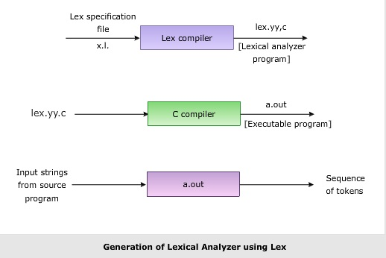
Format for Lex file
The general format of Lex source is:
{definitions}
%%
{rules}
%%
{user subroutines}
where the definitions and the user subroutines are often omitted. The second %% is optional, but the first is required to mark the beginning of the rules. The absolute minimum Lex program is thus %% (no definitions, no rules) which translates into a program which copies the input to the output unchanged.

Regular Expression
A regular expression (or RE) specifies a set of strings that matches it; the functions in this module let you check if a particular string matches a given regular expression (or if a given regular expression matches a particular string, which comes down to the same thing).
Regular expressions can be concatenated to form new regular expressions; if A and B are both regular expressions, then AB is also a regular expression. In general, if a string p matches A and another string q matches B, the string pqwill match AB. This holds unless A or B contain low precedence operations; boundary conditions between A and B; or have numbered group references. Thus, complex expressions can easily be constructed from simpler primitive expressions.Regular expressions can contain both special and ordinary characters. Most ordinary characters, like "A", "a", or "0", are the simplest regular expressions; they simply match themselves. You can concatenate ordinary characters, so last matches the string 'last'. (In the rest of this section, we'll write RE's in this special style, usually without quotes, and strings to be matched 'in single quotes'.)
Some characters, like "|" or "(", are special. Special characters either stand for classes of ordinary characters or affect how the regular expressions around them are interpreted.
Lex Library Routines
Lex library routines are those functions which have a detailed knowledge of the lex functionalities and which can be called to implement various tasks in a lex program.
The following table gives a list of some of the lex routines.
Lex Routine | Description
Main() | Invokes the lexical analyzer by calling the yylex subroutine.
yywrap() | Returns the value 1 when the end of input occurs.
yymore() | Appends the next matched string to the current value of the yytext array rather than replacing the contents of the yytext array.
yyless(int n) | Retains n initial characters in the yytext array and returns the remaining characters to the input stream.
yyreject | Allows the lexical analyzer to match multiple rules for the same input string. (The yyreject subroutine is called when the special action REJECT is used.)
yylex() | The default main() contains the call of yylex()

Answer the Questions:

- Why is –ll option used for running lex.yy.c
Ans. The file lex.yy.c may be compiled and linked in the same way as any C program. The -ll option is used to link the object file created from this C source with lex library:

cc lex.yy.c -ll

The lex library provides a default main() program that calls the lexical analyzer under the name yylex(), so you do not have to supply your own main().

- Use of yywrap
Ans. When the scanner receives an end-of-file indication from YY_INPUT, it then checks the yywrap() function. If yywrap() returns false (zero), then it is assumed that the function has gone ahead and set up yyin to point to another input file, and scanning continues. If it returns true (non-zero), then the scanner terminates, returning 0 to its caller. Note that in either case, the start condition remains unchanged; it does not revert to INITIAL.

- Use of yylex function
Ans. The yylex() as written by Lex reads characters from a FILE * file pointer called yyin. If you do not set yyin, it defaults to standard input. It outputs to yyout, which if unset defaults to stdout. You can also modify yyin in the yywrap() function which is called at the end of a file. It allows you to open another file, and continue parsing.

- What does lex.yy.c. do ?
Ans. The lex command stores the yylex function in a file named lex. yy. c. You can use the yylex function alone to recognize simple one-word input, or you can use it with other C language programs to perform more difficult input analysis functions.

Practical No. E1
Aim: Use the above code (S1) and perform the additional tasks: If a keyword is found append AAA to the identified keyword. For identifier append III. Also add 2 to digit and display the answer

Program:

%{
#include<stdio.h>
#include<string.h>
char text[100],ident[100];
%}

%%
int|float|void|main|char|if|printf|scanf {strcpy(text, yytext);}{strcat(text,"AAA");}{printf("\n%s ",text);}
[-+<>%/=*]|[==]|[!=]|[<=]|[>=] {printf("\n%s is OPERATOR\n",yytext);}
[A-Za-z][A-Za-z0-9]* {strcpy(ident, yytext);}{strcat(ident,"|||");}{printf("\n%s ",ident);}
\".*\" {printf("\n%s is String\n",yytext);}
[{}#()@$:;,?] {printf("\n%s is special symbol",yytext);}
[0-9] {printf("\n%s ",yytext+2);}

%%

int main(void)
{
yyin = fopen("s1.txt","r");
yylex();
}
int yywrap(void){
return 1;
}

Input:
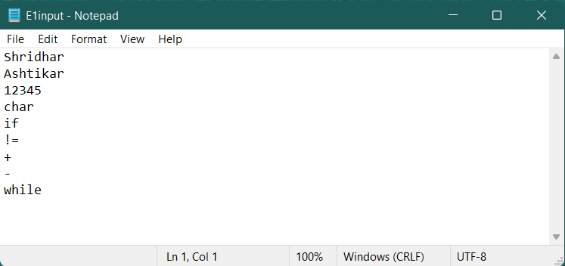

Output:

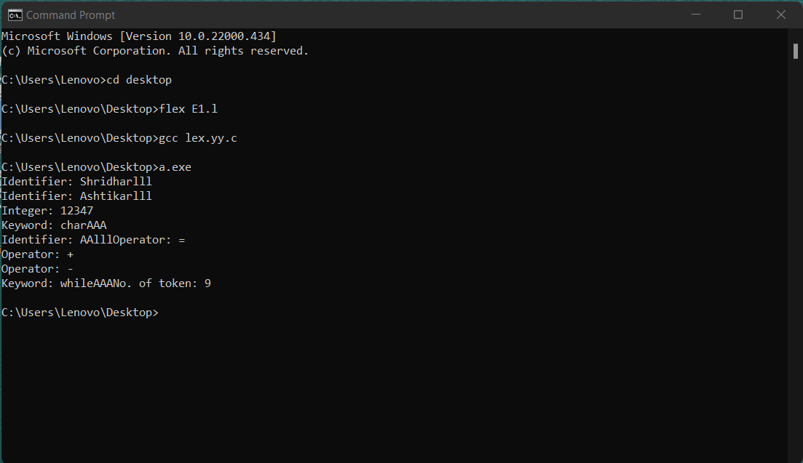

Practical No. E2
Aim: Write a LEX specification to take the contents from a file while adding 3 to number divisible by 7 and adding 4 to number divisible by 2

Program:
%{
#include<stdio.h>
int i=0;
%}
digit [0-9]
%%

{digit}* {i=atoi(yytext);
if(i%7==0 && i%2==0){
printf("%d divisible by 7 : %d (After adding 3)",i,i+3);
printf("\n%d divisible by 2 : %d (After adding 4)",i,i+4);}
else{
if(i%2==0){
printf("%d divisible by 2 : %d (After adding 4)",i,i+4);}
else{
if(i%7==0){
printf("%d divisible by 7 : %d (After adding 3)",i,i+3);}
else{
printf("Digit : %d",i);}}}}

%%

main()
{
yyin=fopen("E2input.txt","r");
yylex();
return 0;
}

int yywrap(){}
Input:

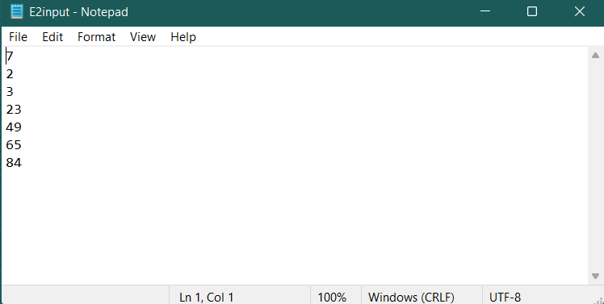

Output:

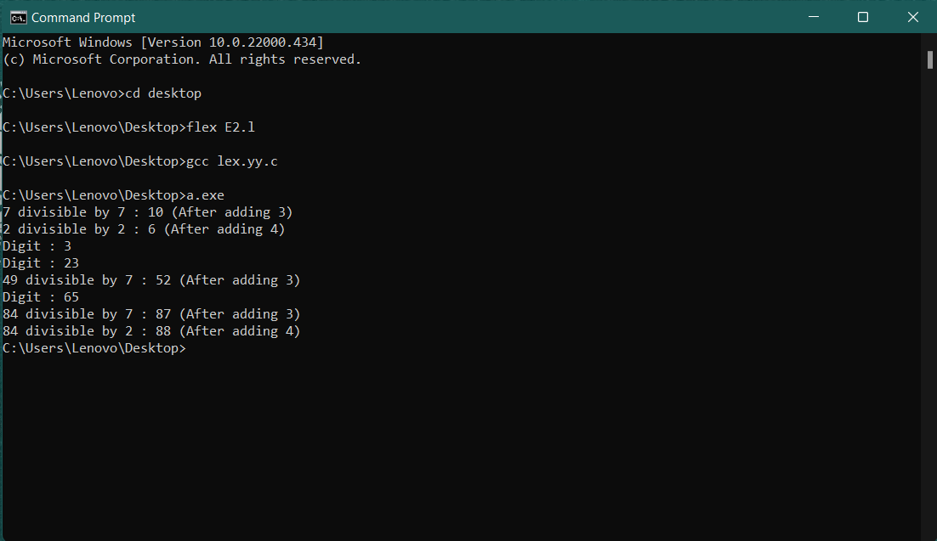

Practical No. E3
Aim: Write a lex specification to display the histograms of length of words

Program:

%{
#include <stdio.h>
#include <string.h>
int arr[100],i;
%}

%%
([a-z0-9A-Z])* {arr[yyleng]+=1;}
[ ]* {}
. {}
"\n" {}
%%

int yywrap(void){}
int main()
{
yyin = fopen("input.txt","r");
yylex();
printf("Length \t Frequency\n");
for(i=0;i<20;i++)
{
if(arr[i]>0)
{
printf("%d \t %d\n",i,arr[i]);
}
}
return 0;
}

Input:
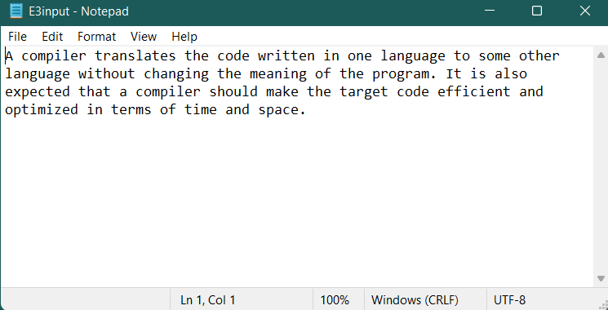

Output:

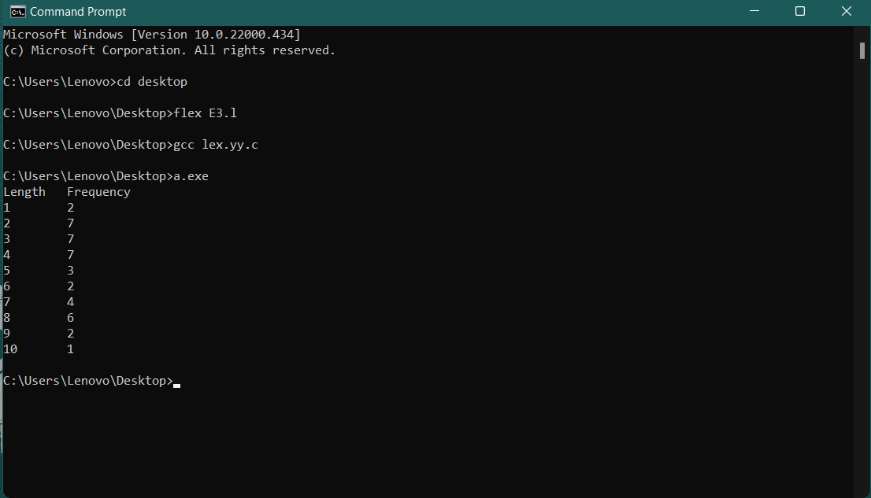

Practical No. E4
Aim: Write a LEX specification to search the input file. Let the input file contain some text,
comments and digits.
(i) Convert text present in file to LOWERCASE.
(ii) Report occurrence of comments and special characters.

Program:
%{
#include<stdio.h>
int SP,C;
%}
sp [!|@|#|$|%|^|&|*|_|(|)|<|>|?|:|"|;|'|.|,]
comment "//"|"/*"[A-Za-z0-9]*"*/"

%%

{sp}+ {SP++;}
{comment}+ {C++;}

%%

main()
{
yyin=fopen("E4binput.txt","r");
yylex();
printf("\nTotal no. of special characters : %d\n",SP);
printf("Total no. of comments : %d\n",C);
}

int yywrap()
{
return 1;
}
Input:

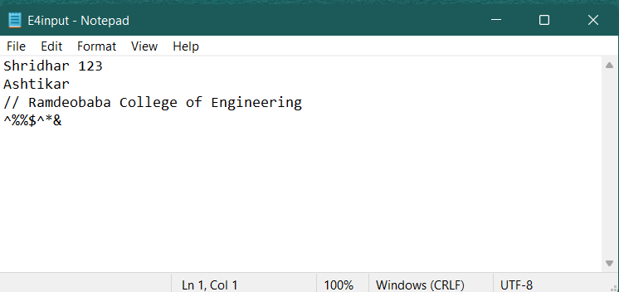

Output:

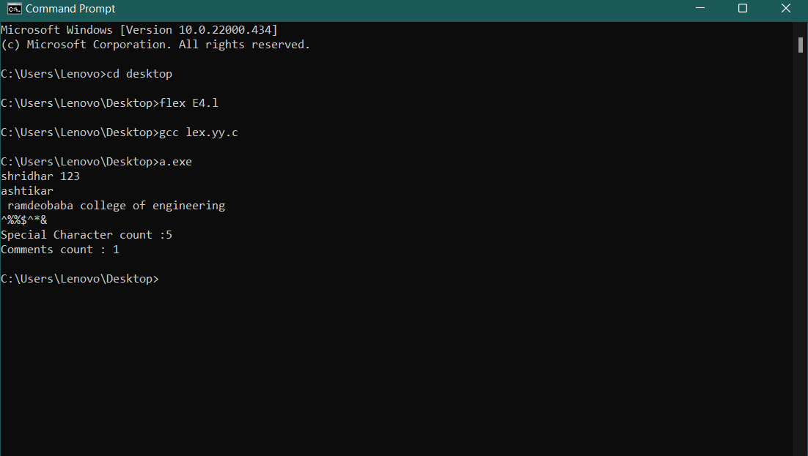

Practical No. E5
Aim: Translate an HTML file with some HTML tags to text file using lex. Consider input from stdin. Discard all HTML tags and comments and write the remaining text to stdout. The text output should simulate the HTML characteristics such as list, indent and paragraphs. Font characters such as bold and italics may not be simulated.

Program:
%{
#include<stdio.h>
#include<string.h>
%}
%%
"<"[^>]*> {}
[a-zA-Z]+ {printf("%s", yytext);}
%%

int yywrap(){}

int main(){
yyin = fopen("E5input.txt","r");
yylex();
}

Input:

HTML Input file:
<p>This is a paragraph! </p>
</br>
<ol>Shopping list
<li>Bread</li>
<li>Butter</li>
<li>Magnets</li>
<li>Paint Brush</li>
</ol>
</br>
<ul>TODO list
<li>Call customer care</li>
<li>Collect parcel</li>
<li>Download Virtual Box</li>
<li>Draft Tasks</li>
</ul>

Output:

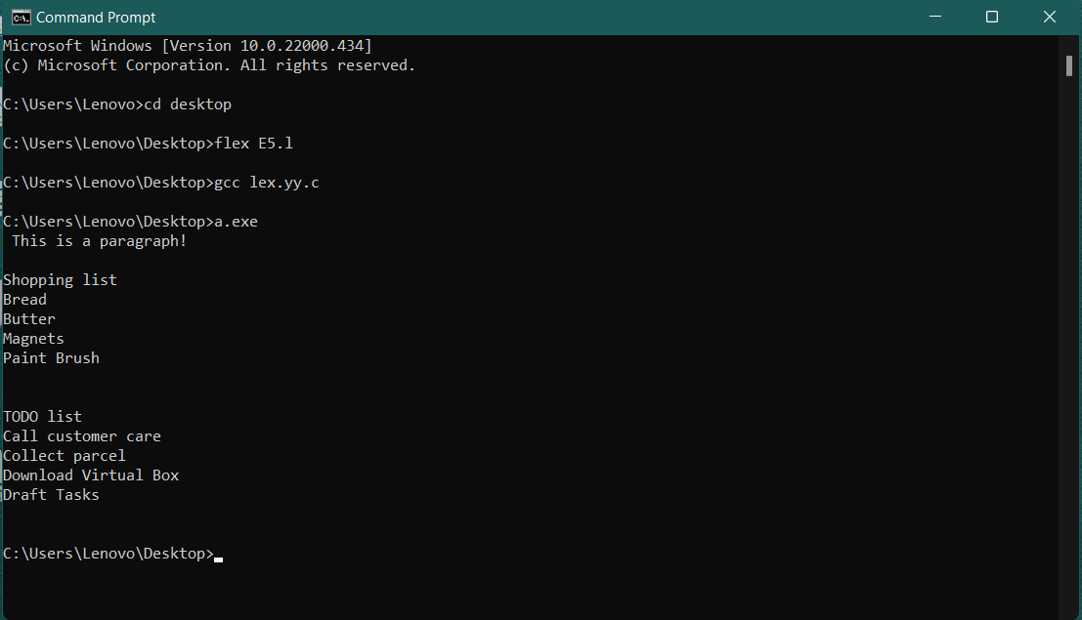

Practical No. E6
Aim: Write a Lex program to find the parameters given below. Consider as input a question paper of an examination and find:
Date of examination, semester, number of questions, number of words, lines, small letters, capital letters, digits, and special characters.

Program:

%{
#include<stdio.h>
#include<string.h>
char date[15],sem[50];
int question=0,words=0,lines=0,small=0,capital=0,digit=0,special=0;
%}

%%

"Sem:".* {
strcpy(sem,yytext);
int i=0;
int space=1;
for(i=0;sem[i]!='\0';i++){
if(sem[i]>='A' && sem[i]<='Z'){
capital++;
}else if(sem[i]>='a' && sem[i]<='z'){
small++;
}else{
special++;
}
}
}

"Question" question++;
\n {lines++;words++;}
[\t ' '] words++;
[a-z]+ small++;
[A-Z]+ capital++;
[0-9] digit++;
[!|@|#|$|%|^|&|*|_|(|)|<|>|?|:|"|;|'|.|,] special++;

[0-9][0-9]"/"[0-9][0-9]"/"[0-9]* {
strcpy(date,yytext);
special+=2;
words++;
int d=0;
for(d=0;date[d]!='\0';d++){
if(date[d]>='0' && date[d]<='1'){
digit++;
}
}
}
%%

main()
{
yyin=fopen("e6input.txt","r");
yylex();
printf("%s\n",sem);
printf("Date is %s\n",date);
printf("No. of Questions: %d\n",question);
printf("No. of Words: %d\n",words);
printf("No. of Lines: %d\n",lines);
printf("No. of Small Letters are %d\n",small);
printf("No. of Capital Letters: %d\n",capital);
printf("No. of Digits: %d\n",digit);
printf("No. of Special Characters: %d\n",special);
}

int yywrap(){
return 1;
}

Input:

Input Text file:

ABC College
1/1/2000 Sem: I, II, III, IV, V, VI, VII, VIII

Question1 : What are the benefits of tree plantation?
Question2 : What is water pollution?
Question3 : What should be done to avoid road accidents?
Question4 : What are your view on noise pollution?
Question5 : Why should people adopt pets?
Question6 : What is green gym?
Question7 : What norms must pe implemented to minimize the loss from construction to environment?
Question8 : What is air pollution?

Output:

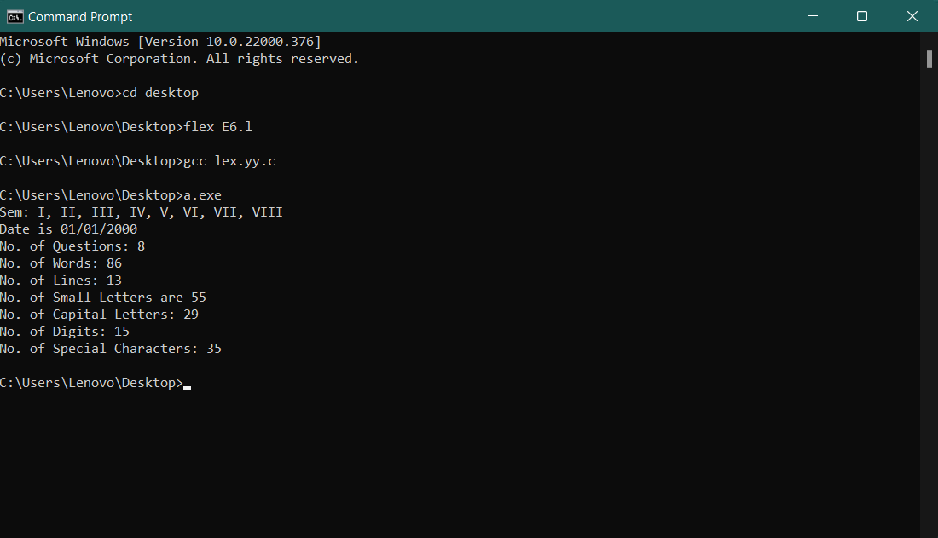

Practical No. E7
Aim: Create a txt file to containing the following without heading: Name of Student, Company Placed in (TCS, Infosys, Wipro, Accenture, Informatica), Male/female, CGPA (floating point number), Department (CSE, IT, EC), Package (floating point number), mail id, mobile number (integer exactly 10 digits). At least 25 records must be present.
- Write a Lex program to find the parameters given below:
  - Identify Name of student and display it.
  - Identify CGPA and display (should be less than 10)
  - Identify Package and display it
  - Identify mail id and display
  - Identify mobile number and display
  - Find number of students placed in each of the company
  - Number of female students
  - Number of male students
  - Number of CSE, IT and EC students who are placed

Program:

%{
#include<stdio.h>
#include<string.h>
%{
#include<stdio.h>
#include<string.h>
int tcs=0, infosys=0, wipro=0, accenture=0, informatica=0, male=0, female=0, cse=0, it=0, ec=0;
%}

%%
"TCS" tcs++;
"Infosys" infosys++;

"Wipro" wipro++;

"Accenture" accenture++;

"Informatica" informatica++;

"Male" male++;

"Female" female++;

"CSE" cse++;

"IT" it++;

"EC" ec++;

[A-Z][a-z]+ {printf("\nName: %s",yytext);}
[0-9]"."[0-9]+ {printf("\nCGPA: %s",yytext);}
[0-9]{6} {printf("\nPackage: %s",yytext);}
[a-z]*"@"[a-z]+ {printf("\nMail id: %s",yytext);}
[0-9]{10}+ {printf("\nMobile: %s",yytext);}

%%

main(){
yyin = fopen("E7input.txt","r");
yylex();
printf("\nNo. of students placed in TCS: %d",tcs);
printf("\nNo. of students placed in Infosys: %d",infosys);
printf("\nNo. of students placed in Wipro: %d",wipro);
printf("\nNo. of students placed in Accenture: %d",accenture);
printf("\nNo. of students placed in Informatica: %d",informatica);
printf("\nNo. of Male candidates: %d",male);
printf("\nNo. of Female candidates: %d",female);
printf("\nNumber of CSE candidates: %d",cse);
printf("\nNumber of IT candidates: %d",it);
printf("\nNumber of ECE candidates: %d",ec);
}

int yywrap(){
return 1;
}
Input:

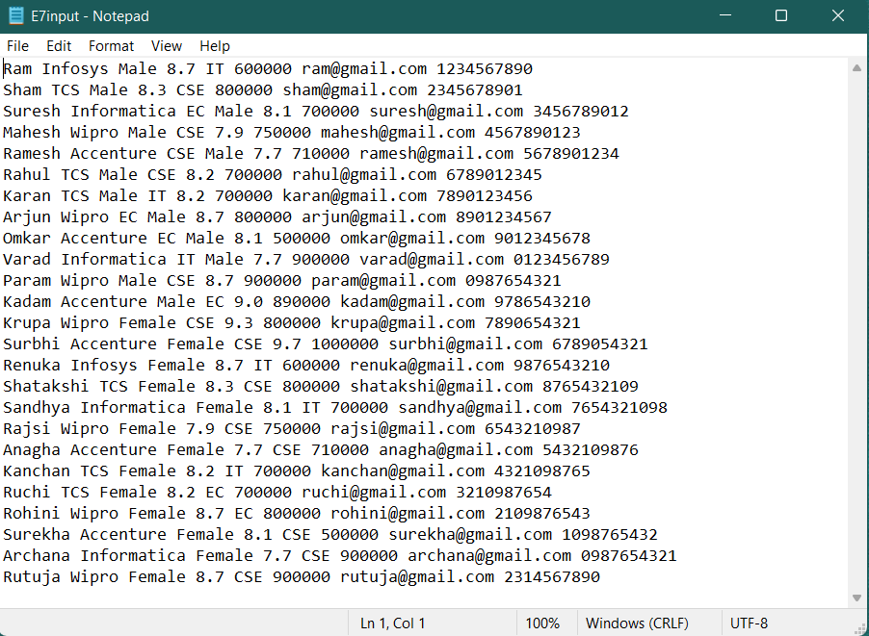

Output:

